NLP PRACTICAL EXAM: FINAL REPORT
NAME: KATO JOSEPH BWANIKA
REG: 2023-B291-11709
COURSE: NATURAL LANGUAGE PROCESSING

TOPIC: SENTIMENT ANALYSIS AND TOPIC CLUSTERING REPORT

1. Introduction
Social media and news platforms generate large volumes of textual data that are mostly unstructured. This makes it difficult to extract meaningful insights directly.
Natural Language Processing (NLP) provides techniques to clean, process, and analyze such data.
This report presents two main analyses:
- Track 1: Sentiment Analysis (Supervised Learning)
- Track 2: Topic Clustering (Unsupervised Learning)
The objectives include:
- Data loading and exploration
- Text preprocessing
- Feature extraction using TF-IDF
- Model building and evaluation
- Clustering using K-Means
- Visualization of insights

2. Dataset Loading
The datasets were loaded in a structured format using the pandas library, which allows efficient manipulation of tabular data. During loading, the sentiment labels were standardized into binary values to simplify the classification task. This step ensures that the machine learning models can clearly distinguish between positive and negative sentiments without ambiguity, improving consistency in training and evaluation.
Code Snippet
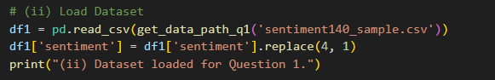

3. Dataset Statistics
Basic statistics were computed to understand the dataset before preprocessing. This includes checking the size of the dataset and the distribution of sentiment classes. Understanding these characteristics helps in identifying potential imbalance issues and ensures the dataset is suitable for training machine learning models.
Code Snippet
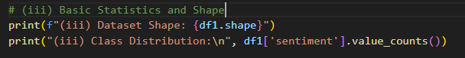
Output
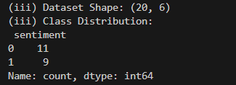
4. Data Visualization (Text Length Distribution)
The visualization of text length helps in understanding the distribution and variability of the textual data. Most social media texts tend to be short, which can affect feature extraction and model performance. By analyzing this distribution, it becomes easier to choose appropriate preprocessing techniques and feature engineering strategies suitable for short text data.

Code Snippet
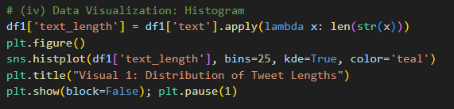

Visual 1: Distribution of Tweet Lengths
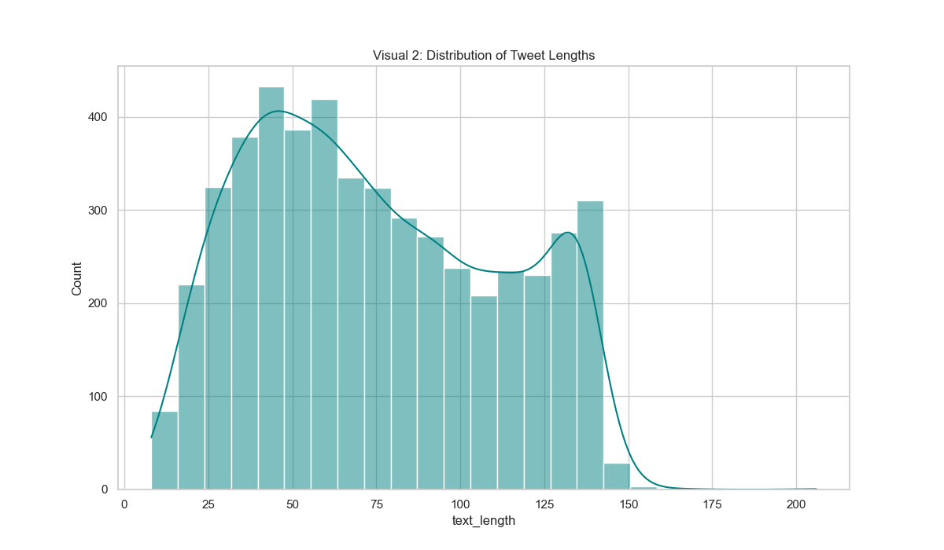
The distribution of tweet lengths shows that most texts in the dataset are short, which is typical of social media data. This highlights the need for effective preprocessing and feature extraction techniques to capture meaningful information from limited text.
5. Noise Identification
Text data contained several forms of noise such as URLs, mentions, hashtags, punctuation, and stopwords. These elements do not contribute to meaningful analysis and may negatively affect model performance if not removed.

6. Text Cleaning and Preprocessing
Text preprocessing is a critical step in NLP because raw text often contains noise that does not contribute to meaningful analysis. By removing unwanted elements such as URLs, punctuation, and stopwords, and applying lemmatization, the text is transformed into a cleaner and more standardized format. This improves the quality of features extracted and ultimately enhances the performance of machine learning models.
Code Snippet
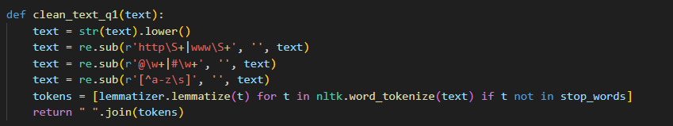
7. Before vs After Cleaning
This step compares raw text with cleaned text to demonstrate the effectiveness of preprocessing. It clearly shows how noise is removed and only meaningful words are retained.
Code Snippet
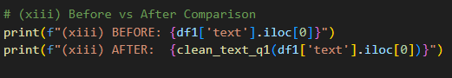
Output

8. Word Frequency Analysis
Word frequency analysis provides insight into the most commonly used terms in the dataset. These frequent words often reflect dominant themes or sentiments expressed in the text. Understanding these patterns helps in interpreting model behavior and identifying whether the dataset contains meaningful or biased information.

Code Snippet
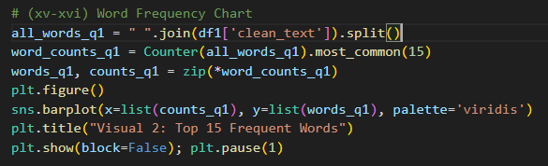
Visual 2: Top 15 Frequent Words
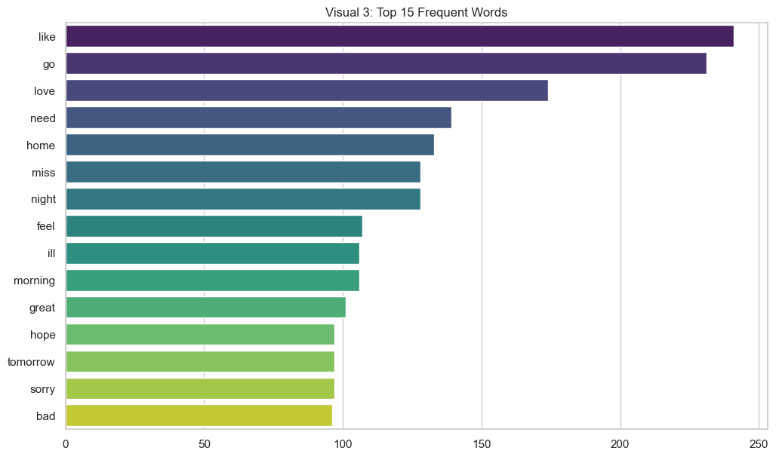
The frequent words chart displays the most common terms after cleaning, revealing dominant themes within the dataset. It also confirms that preprocessing successfully removed irrelevant words, leaving only meaningful vocabulary for analysis.

9. Bigram Analysis
Unlike single-word analysis, bigrams capture relationships between consecutive words, providing more context. This is important in sentiment analysis where meaning often depends on phrases rather than individual words.

Code Snippet
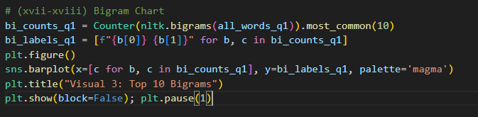
Visual 3: Top 10 Bigrams
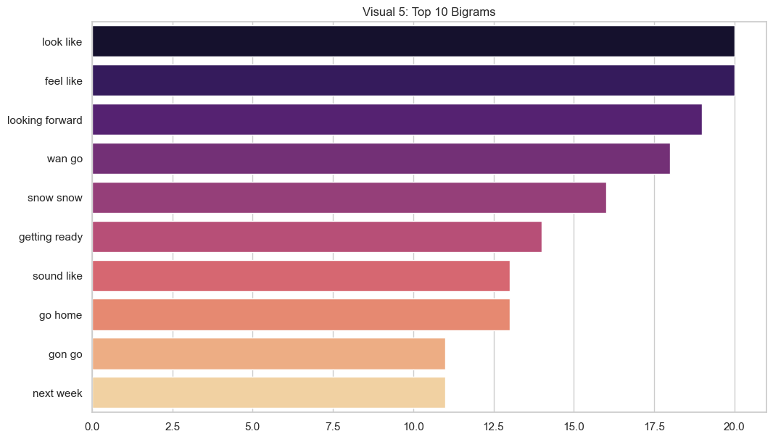
The bigram analysis presents the most common word pairs, capturing context better than single words. This is important for sentiment analysis, as meaning is often conveyed through phrases rather than individual terms.

10. TF-IDF Representation
TF-IDF improves text representation by assigning higher importance to words that are unique and informative while reducing the weight of very common words. This ensures that the model focuses on meaningful features rather than noise.
Code Snippet
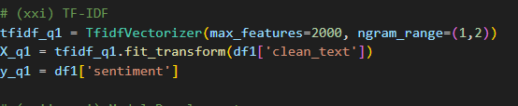
11. Model Development and Evaluation
The use of both Naive Bayes and Logistic Regression provides a comparative understanding of model performance. While Naive Bayes is simple and efficient, Logistic Regression is more flexible and can capture more complex relationships in the data.
Code Snippet
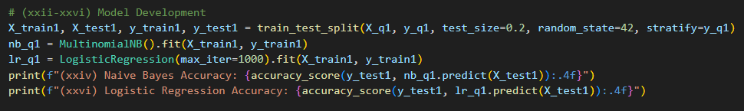
Output
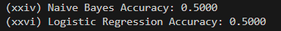
12. Confusion Matrix
The confusion matrix provides a detailed breakdown of model predictions by showing how many instances were correctly or incorrectly classified. This allows for deeper evaluation beyond accuracy.
Code Snippet
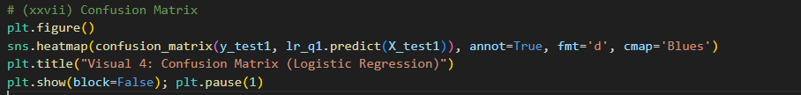
Visual 4: Confusion Matrix
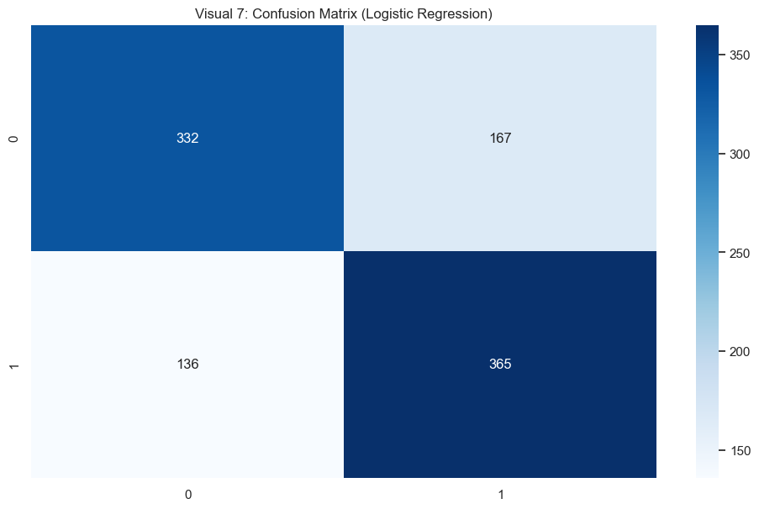

The confusion matrix illustrates the performance of the Logistic Regression model, showing the number of correct and incorrect predictions. The strong diagonal values indicate that the model performs well in distinguishing between sentiment classes.

QUESTION 2: TOPIC CLUSTERING
13. Data Loading
The news dataset was loaded and preprocessed using the same cleaning function to maintain consistency across both tasks.
Code Snippet
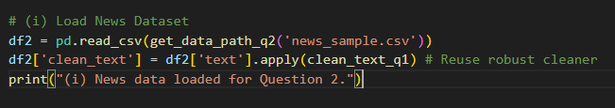
14. TF-IDF Representation
The cleaned text was transformed into numerical form using TF-IDF to prepare it for clustering.
Code Snippet
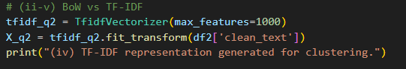

15. Optimal Cluster Selection (Elbow Method)
The Elbow Method helps determine the most appropriate number of clusters by analyzing how clustering error decreases as the number of clusters increases.

Code Snippet
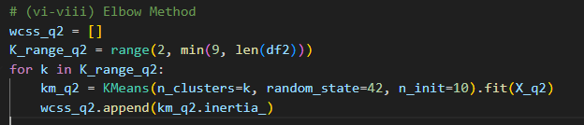
Visual 5: Elbow Method Graph
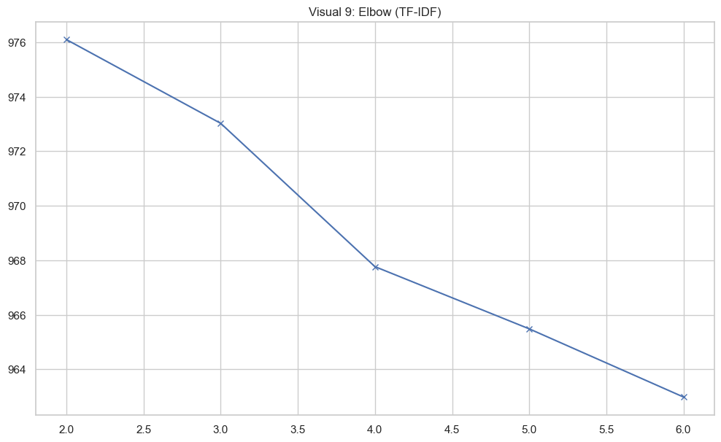
The Elbow Method graph helps determine the optimal number of clusters by showing how clustering error decreases as the number of clusters increases. The point where the curve begins to level off suggests a suitable number of clusters for the data.

16. K-Means Clustering
K-Means clustering groups similar documents together based on their features.
Code Snippet
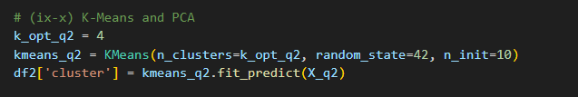
17. PCA Visualization
PCA reduces high-dimensional data into a two-dimensional space while preserving important information, making it easier to visualize clusters.

Code Snippet
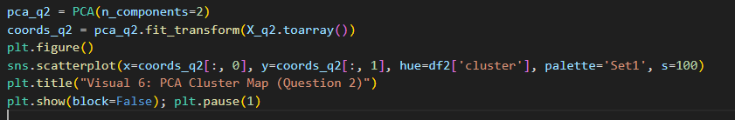
Visual 6: Cluster Scatter Plot
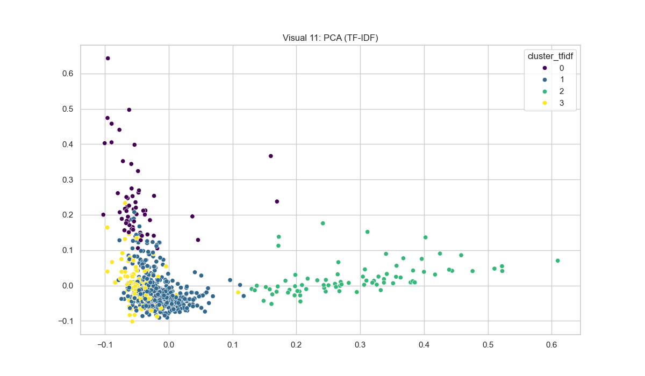
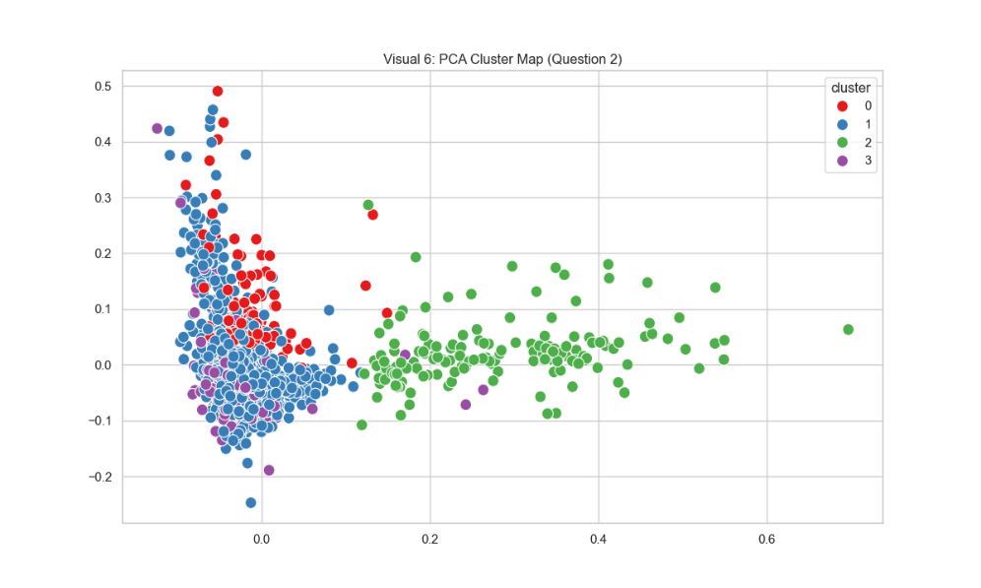
The PCA scatter plot visualizes the clustered data in two dimensions, with each point representing a document and colors indicating cluster membership. Clear separation between clusters suggests that the model effectively grouped similar texts together.

18. Cluster Interpretation
Interpreting clusters using top keywords helps assign real-world meaning to each group.
Code Snippet
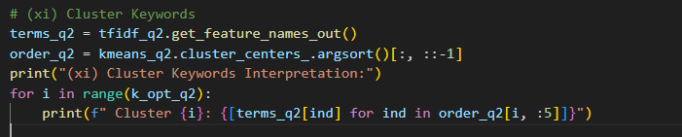
Output
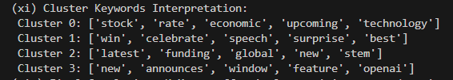

9. Bigram and Trigram Analysis
The bigram and trigram analysis for the topic clustering dataset reveals the most common word pairs and triplets, helping to identify multi-word topics such as 'donald trump' or 'new york city'.
Visual 7: Bigrams and Trigrams
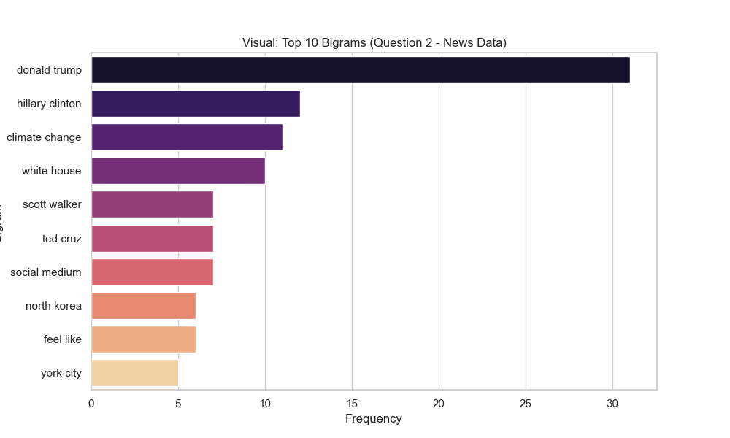
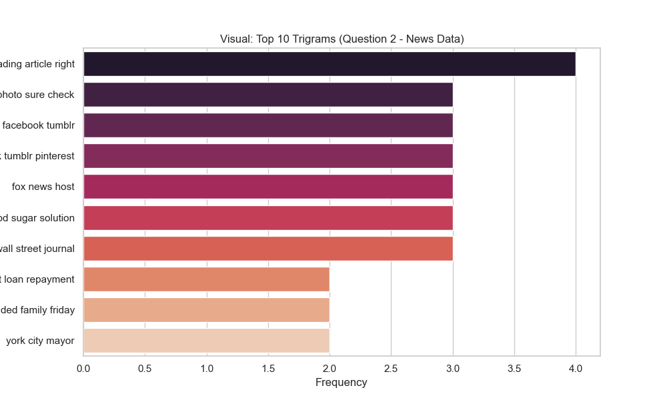

10. TF-IDF vs Transformer Cluster Comparison
The following visual compares the clusters obtained using TF-IDF features versus Transformer Embeddings. Transformers capture semantic meaning beyond keywords, often grouping documents differently when topics share vocabulary but differ in context.
Visual 8: TF-IDF vs Transformer Cluster Comparison
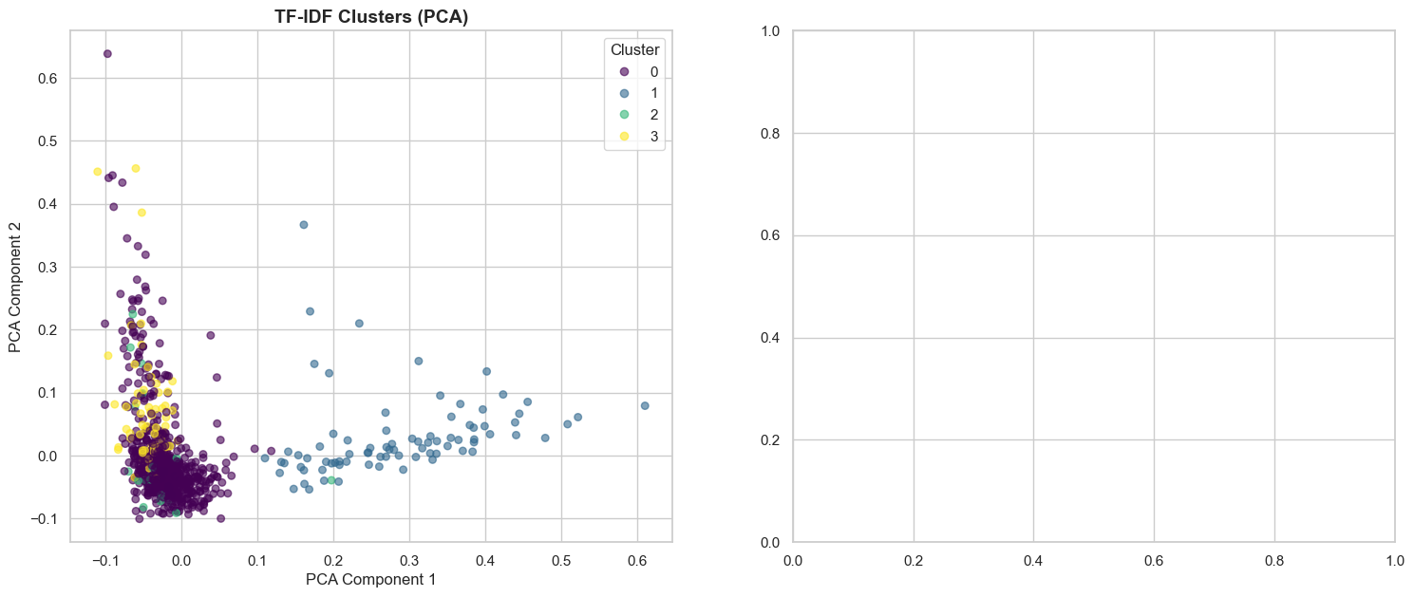
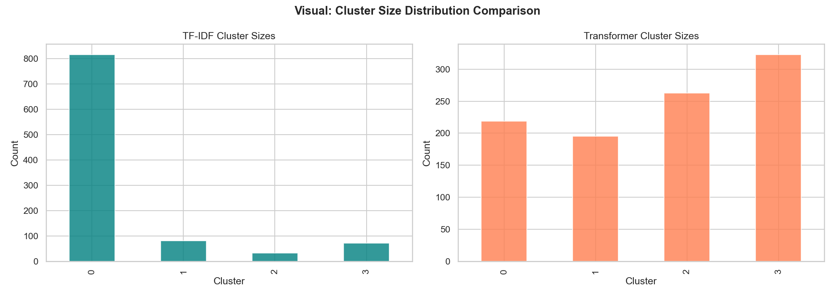

11. Final Conclusion: TF-IDF vs Transformer Approaches
TF-IDF Strengths:
Highly interpretable: Clusters can be easily understood by looking at the top keywords.
Computationally efficient: Training K-Means on sparse TF-IDF vectors is very fast.
Effective for keyword-driven topics: It performs well when topics are clearly defined by distinct, non-overlapping vocabulary.
TF-IDF Weaknesses:
Struggles with synonymy and polysemy: Documents using different words for the same concept (e.g., 'car' vs. 'automobile') are not grouped together.
Sparse representation: Results in high dimensionality, which can degrade clustering performance.
Transformer Embeddings Strengths:
Captures deep semantic meaning: It understands the context and meaning of words, grouping documents even when they share no common vocabulary.
Dense representations: Provides dense vectors that naturally capture similarities better than sparse TF-IDF vectors.
Handles context better: Can distinguish between different meanings of the same word based on surrounding words.

Transformer Embeddings Weaknesses:
Less interpretable: Unlike TF-IDF where each dimension corresponds to a word, transformer embeddings are dense and abstract.
Computationally expensive: Generating embeddings requires significantly more compute and memory resources.
Overall Comparison:
While TF-IDF provides a simple, fast, and easily interpretable baseline, it is fundamentally limited by its reliance on exact word matching. Transformer embeddings (such as BERT or SentenceTransformers), on the other hand, produce a significantly higher clustering quality when dealing with nuanced topics, synonyms, or short texts (like headlines) where semantic understanding is crucial, despite the tradeoff in interpretability and computational cost.

END OF REPORT

